SAMPLE PRESS RELEASE
FOR IMMEDIATE RELEASE

For more information, call:
Name: Herbert Ford
Number: 240-485-7671

Lester Young Jr., Convicted Murderer Turned Successful Motivational Speaker, and
Hilton Head Native, coming to Island to Speak to Youth

Hilton Head Island, SC-December 27, 2015 -At age 18, Lester M. Young, Jr., a native of Hilton Head Island, was convicted of murder and sentenced to life in prison. After 22 ½ years of imprisonment, Young was released and now has a message to share with youths.

Now a successful motivational speaker who used prison to turn his life around, Young will come to Hilton Head Island on Saturday, January 9th, 2016, to speak about the Power of Choices at a community youth program. The program, aimed at youths between the ages of 13 and 25, will take place from 1:30 to 3:30 p.m. in the Richard Cyr Community Room at the Hilton Head Public Service District #1 office, 21 Oak Park Drive, Hilton Head.

“In light of the violent tragedies that have occurred in our community over the year, we felt the need to gather our youths and help guide them in the right direction,” said Herbert Ford, who is part of a group of concerned citizens organizing a series of seminars to stimulate and motivate youth in the community.

The program featuring Young is the first of several that will be held, Ford said. In addition to Young’s talk, the group plans to host sessions on careers, conflict management, financial management, college options, culture and other talks.

“Our objective is to foster the spiritual growth, intellectual development, personal maturation, Gullah cultural enrichment, professional exposure and networking potential for our youth participants,” Ford said. The seminars would help instill integrity, respect, professionalism, ethics and loyalty.

“We are reaching out to our educational, civic and religious leaders, and community and business partners for their support in making our objective a reality,” Ford said.

Ford said group members were aware of the Lester Young Jr., his troubled youth and his successful turnaround, and felt he would be the ideal person to kick off the series.

“Mr. Young has agreed to speak frankly about his life and experiences growing up on Hilton Head and how he made some personal choices that resulted in his long-term incarceration. His presentation is geared towards sparking a realistic vision of what could happen to anyone who fails to take advantage of the educational resources and opportunities of professional development. We are fortunate that he is willing to share how he has evolved,” Ford said.

During his time in prison, Lester watched young men coming to prison and realized he wanted to be a voice to help at risk youth. That’s when he embarked on a change. With support of family and friends, Young obtained his G.E.D and enrolled in Business Management Courses via mail at Ashworth College.
After his release from prison, Young continued to help others. He founded a non-profit organization, “Path2Redemption Institute”. The organization’s mission is to assist ex-offenders with housing, support groups, and teaching basic life skills essential for a successful transition back into society. In addition to helping ex-offenders, Young conducts workshops for youth and counsels them on the power of choices.

For more information or to register youth for the program, call 240-485-7671.
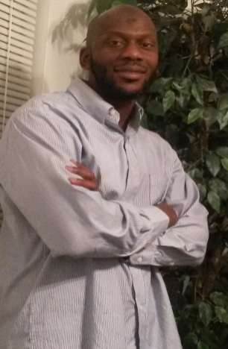
Photo Cutline: Lester Young Jr.

